

**Espire Infolabs Private Limited**

Software Division

Integrated Quality Management System

**Low level Design Document**

Project Name: DWP DPMS Low Level Document

**Client Name** WilliamsLea

**Version**: 0.1

**Reference:** ESPIRE/ IQMS/OM/FMT/G099

**Security Classification**: Internal

**Issue Date:** Oct 10, 2019

**Note**: The Text highlighted in Blue color contains Guidelines Text (<< >>) for filling Template or template specific information. Please edit and remove all text highlighted in Blue color from final version of Project document. Use Black font on editing the Text in blue.

|  |  |  |  |
| --- | --- | --- | --- |
| Document Control | | | |
| **Reference No.** | ESPIRE-IQMS-OM-FMT-G099 | | |
| **Document Name** | Design Document Template | | |
| **Version No.** | 0.1 | | |
| **Document Status** | Definitive | | |
| **Issue Date** | Oct 10, 2019 | | |
| **Compliance Status** | Mandatory | | |
| **Review Period** | One year from the date of release or earlier if required | | |
| **Security Classification** | Internal | | |
| **Distribution** |  | | |
|  | **Name** | **Role** | **Signature** |
| **Authored by** | Vikas Tripathi | Sr. Software Engineer | Vikas |
| **Reviewed by** | Niladri | Solution Architect | Niladri |
| **Approved by** | Yogesh Gupta | DGM | Yogesh |
| **Released by** | Vikas Tripathi | Sr. Software Engineer | Vikas |

|  |  |  |
| --- | --- | --- |
| Document Revision History | | |
| **Version** | **Release Date** | **Change Description** |
| 0.1 | Oct 10, 2019 | Original Version |
|  |  |  |
|  |  |  |
|  |  |  |

CONTENTS

1. Introduction 4

1.1 Purpose 4

2. Objective 4

3. Scope 4

3.1 In-scope 4

4. References 5

5. Stakeholders 5

6. Design Architecture 6

6.1 Application Workflow 7

6.2 DWP – DPMS Print System Solution 8

7. Solution Overview 8

7.1 User Login (TBD) 8

7.2 Users & Role 9

7.3 User Registration 10

7.4 User List (TBD) 11

7.5 File View 12

7.5.1 - File View for Holding/ Manual Process 12

7.5.2 - File View for Completed Process 13

**7.6 Post Processing 16**

**7.7 Pre-Requisites 18**

**7.8 Assumption 19**

**7.9 Standard and Guidelines 19**

**7.10 Package 19**

7.10.1 Class Name 19

7**.11 Database Design** 20

# Introduction

DPMS is a solution currently deployed on the DWP VME mainframes that provides various functionality to the Print Support Team (PST) as well as the print operators in both Shepshed and Abbey View.

## Purpose

The purpose of this document is to define business scenarios, use cases, technical specification etc.

# Objective

The objective is the web portal GUI will be used by both the Print Support Team as well as Print Operators in production to control and manipulate files that are stored on the File Routing server. The portal will be a simple system with a list of all the files available on the server and have the following functionality

The web portal will have User Access Control managed via an Active Directory group that will be created by WL to allow staff access to the portal URL. This UAC needs to be integrated into the portal. The portal will have a simple interface that is easy to navigate for users who may not be particularly technically minded

# Scope

## In-scope

* Have the ability to automatically route individual files to Abbey View or Shepshed based on file name.
* Have the ability for the designated support team to change the print site destination.
* Have the ability for the designated support team to change the "WL Filename" applied to incoming files at file level.
* Based on file name, can release individual files automatically to Lasermail or hold for manual release.
* Provide a mechanism to change whether individual files are configured to be released automatically or held for manual release.
* Provide a user-friendly searchable interface for the manual release of individual files or groups of files by the print operators.
* Have the ability for the designated support team to resubmit a copy of an individual file to either production site on request within the constraints of the agreed data retention period.
* Present to Gandlake the file names which include the “WL Filename” parameter.
* Automatically securely delete files at the end of the agreed retention period.

# References

[This document will take reference from SRS, SAD (Software Architecture Document) and Design Model implemented using UML]

# Stakeholders

|  |  |
| --- | --- |
| **Stakeholders** | **Roles & Responsibility** |
| Vikas Tripathi, Saiyed | SSE, Developer |
| Vikas Tripathi, Saiyed | SSE, Author of this document |
| Niladri, JD | PL, Requirement analysis and handling team |
| Yogesh Gupta | DGM, Approver |

# Design Architecture

* Documentation:
* **Users**: There are mainly two categorizations of users in DPMS system, namely administrators and operator. All configurations are managed by admin and feature of print job lifecycle.
* **Virtualization containers:** Hypervisor based Docker deployment model to handle the non-functional requirements such as vertical and horizontal scaling, availability, load balancing and failover recovery, etc.
* **Kubernetes Engine**: This is a container orchestration engine that manages the virtualization and docker hosting management. This can be hosted on windows as well as Linux platforms.
* **DPMS Web App**: this is the frontend GUI or the website for the users to manage, control and execute the print data flow of DPMS system. This is a single page application (SPA) build on Angular JS and Bootstrap framework to support multiple devices, platform, browsers and screen resolutions. In future it can be extended as a mobile app too if required.
* **API Gateway**: This is the api controllers and manages the flow and load over APIs.
* **Core Services**: These are the system functional APIs that manages the CRUD operations triggered by user interactions on Web App.
* **Integration Agents**: These are special APIs that are connected to third party systems to exchange data and control.
* **Platform Service**: These are the support system service for memory management and interservice communication and messaging.
* **Window Service**: This is a window hosted service which interacts with the web App and APIs for control and communicate with GlobalScape and SFTP servers to manage file transfers.
* **SQL Database**: This is a database instance to store file related information and status logging with audit trail.
* **Active Directory service**: This is used for domain user's authentication.

## Application Workflow

* Diagram:

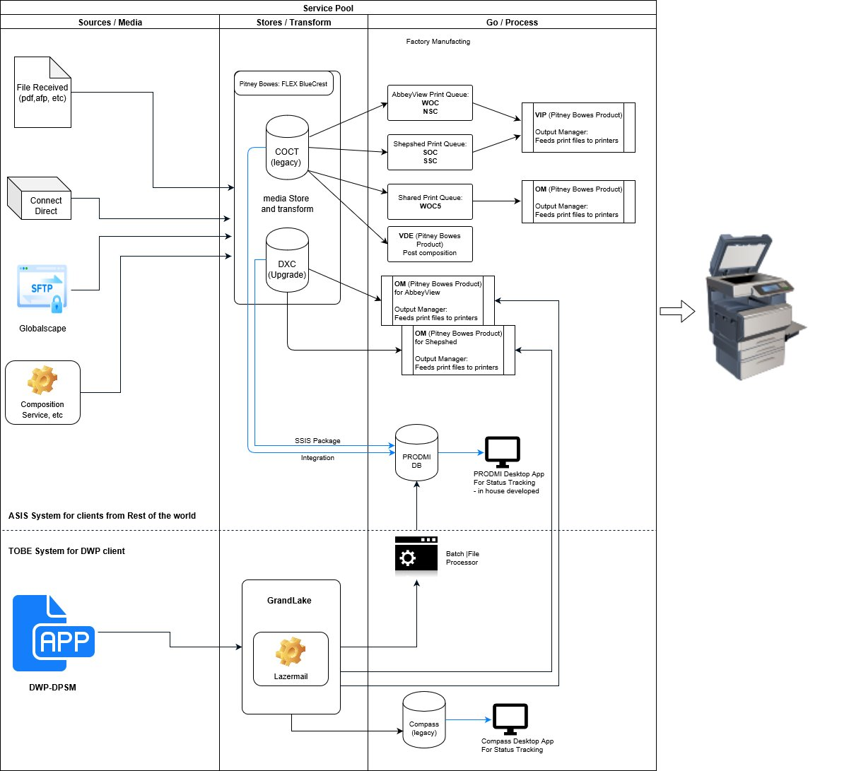

## DWP – DPMS Print System Solution

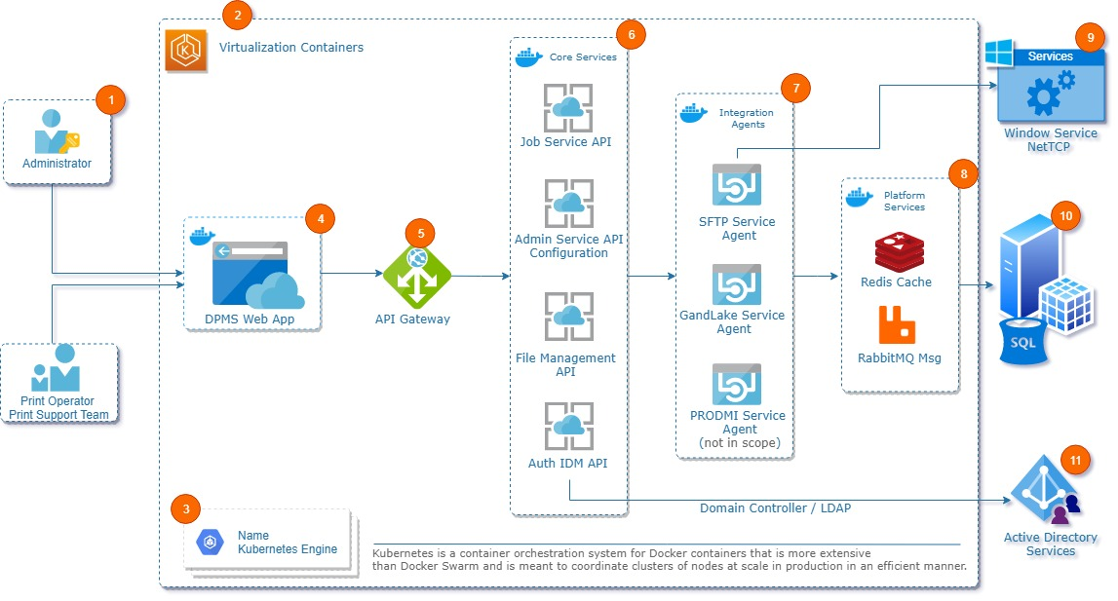

# Solution Overview

## User Login (TBD)

# 7.2 Users & Role

There are three user Admin, Print Support Team (PSO) and third one is Print Operation Team (POT). Hence, home page or landing page will be decided as per the logged user. For example.

* **Admin user** will be landed by default on User List page. And it can access User Registration and User List page.
* **Print Support Team** will be landed by default on Manual Processing File List page. Print Support team can have full access and Print Ops Team can have read-only access on this page and can perform operations as per the Admin provided rights.
* **Print Ops Team** will be landed by default on Completed Processing File List page. Print Support team can have read-only access and Print Ops Team can have full access on this page and can perform operations as per the Admin provided rights.

We will introduce below login screen for user login-

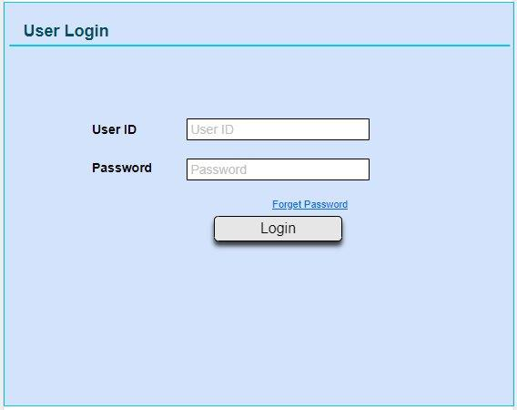

We will introduce forget password and change/reset password feature also.

* The password must be at least 8 characters long.
* Functionality is required to set a temporary password for a user – (The password is to be system generated and adhere to the password rules)
* Functionality is required to set a reset a user’s password. – (The password is to be system generated and adhere to the password rules)

# 7.3 User Registration

For User registration we will have registration view page with given fields below-

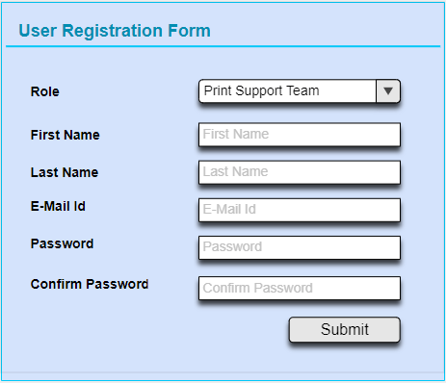

* User Type will define the support group of users and it can be from Print Support Team or Print Operation Team. Its size is of 50 characters.
* First Name defines first name of user and can contains 50 characters.
* Last Name defines last name of user and can contains 50 characters.
* Email ID is unique and can contains 100 characters.
* Password is alphanumeric must have alphabet number and one special character and can contains 20 characters.
* Confirm password should be same as password.
* User ID should be unique, its size is of 50 characters.

# 7.4 User List (TBD)

We will show here all registered user (Print Support Team and Print operation Team) and it would be searchable -

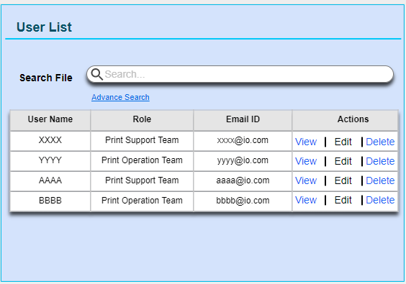

* View option will provide to show all information to corresponding user and it should be read-only.
* Edit option will provide to show all information to corresponding user and it should be editable and update the same record as you want.
* Delete option will permanently delete to corresponding user from DB and user list also.

# 7.5 File View

Those files which belongs to aged people’s pension plan, can be viewed here and support team can send these files for print when print house has less bandwidth

### 7.5.1 - File View for Holding/ Manual Process

Print Support team can have full access and Print Ops Team can have read-only access on this page and can perform below operations.

* All “Manual” routing files can be seen here.
* User can also view and change, operator(destination) to print the file. currently we have two operators “Shepshed” and “Abbey View”.
* By selecting files and choosing the operator will change the file name accordingly and will move the file to “Completed (Tab-2)” after the “Submit”.

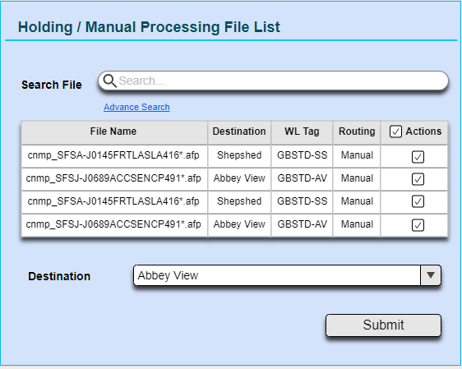

* This screen will also allow user to select single or multiple files, to choose operators according to the load on print house (Shepshed/ Abbey View).
* Print service will push the files to print location based on file name, so by clicking the submit button file names will set according to selected operator.
* It will amend the WL Tag with the filename and the suffix is to be added at the end of file name.

For E.g. [FileName] + [WL Tag] . [FileExtention]

becomes cnmp_SFSA-J0145FRTLASLA416*_GBSTD-SS.afp

**Advance Search:**

Provide a user-friendly searchable interface for the manual processing file list.

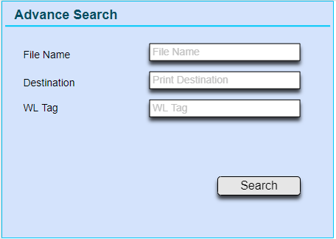

### 7.5.2 - File View for Completed Process

Print Support team can have read-only access and Print Ops Team can have full access on this page and can perform below operations.

* All “Automated & Manual” routing files can be seen here.
* User can search files and download by clicking on it’s name.
* User can select single or multiple files to send it for printing.

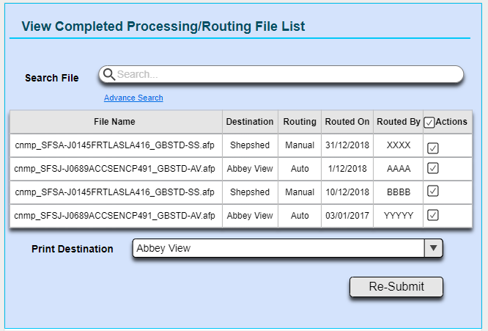

* By clicking on “Re-Submit” button it will send the file to print location as well as it will create logs files as well.
* All input files will have their original filename and amended WL filename saved in a log file.
* Log files can later be used for ingestion into PRODMI. This ingestion is out of scope of this design, but the log files will be created here.
* Log structure TBD.
* Further this log will be used to generate a report at DPMS to verify the results which would go back to DWP govt Dept for filling.

**Retained Files**

All files after printing can be seen here for given retention period.

* Retention period can be changed for all files, so we have to store the value of retention period in app settings file.
* We will save only the path into the database of all files with their name and time of creation.
* Files can be viewed by clicking on file name and it will download the file on local machine.
* All input files will be held in the folders and retained for a period of [TBD] days, before being automatically deleted by the File Routing service.
* While deleting the files from retained folder will also mark “IsDeleted” column in database “true” and maintain the time of deleted files in database.
* Search files by selecting dates from calendar will also be available in search box.

**Advance Search:**

Provide a user-friendly searchable interface for the all routed file list.

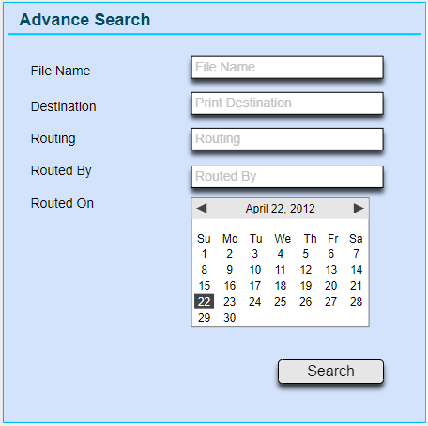

## Post Processing

After the routing process, the files would be transferred to an SFTP location on Grand lake or Globalscape depending upon IP configurations provided.

Only one output service endpoint would be configured. SFTP agent, Globalscape agent and Grandlake agent would be merged into one agent.

There would be multiple instances of DPMS applications running against two datacentres having two private and open SSH based SFTP servers. The file system of the two SFTP servers would be mirrored through networking so you get same copy of files. It’s important we maintain a flag-based approach for processing files.

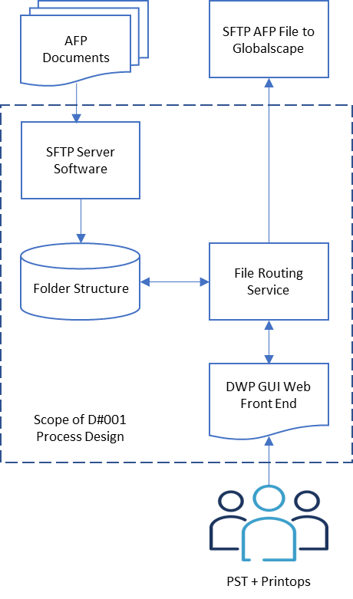

* All files will be placed inside a folder [TBD].
* A window service will keep looking in this folder for files.
* As soon as file arrives windows service will execute and check into database if same file does not exist against status as “Not Processed”.
* If no file found into database it will make an entry into database against received file and mark status as “Processing.”
* Send files for printing and after completing the printing update the status as “Processed” and update the time.

## Pre-Requisites

* Server access, environment setup (Dev and QA) and TFS access (Source control).
* Any required License.
* Dev/Test access to SFTP/ GlobalScape and Gandlake [TBD].
* Data Samples and lookup table.

## Assumption

Folder structure not yet decided hence moving forward with a dev level configuration.

## Standard and Guidelines

This section describes the standard and guidelines, which will be followed in the implementation of the system.

## Package

* Package Name:

*Name of the package*

* Documentation:

*[This section will provide the brief description of each package. ]*

* Interaction Diagram Name:

*[This section will define the name of the interaction diagram.]*

* Interaction Diagram:

[Image of the Interaction diagram will be shown here.]

* Class Diagram Name:

*[This section will define the name of the Class diagram. ]*

* Class Diagram:

[Main class diagram with defined relationship will be shown/referred here]

* Sequence Diagram

This section will provide the sequence diagram for the package.

### Class Name

This section will lists the class description along with details given below for each class of the package.

* Documentation

This section will provide the brief description of each class involved in this package.

* Class Diagram

Class diagram for the class described in this section.

* Attributes

Relevant attributes along with the data type. (The attributes will be represented in the class diagram itself)

* Operations and return types:

Relevant operation signature along with the arguments and return types (the operation signatures will be represented in the class diagram itself). The operation section will also describe the operation briefly.

* Return Type:

This section will define all Return Classes with the return type.

* Pseudo Code:

This section will list the relevant operations along with the pseudo code of the operation.

* Data Interaction:

This section will list the CRUD [Create, Read, Update, Delete] Matrix (if applicable) for the current class.

Note: The class diagram above wills lists only those attributes/operations, which are necessary for implementing business logic of the class. The attributes/operations, which are common or are required for standard function of the class (e.g. GUI components of the class) are not listed in the class diagram.

## Database Design

